7 December 2012

[www.viscomafrica.com](http://www.viscomafrica.com). Keys Communications alternative media R20 000

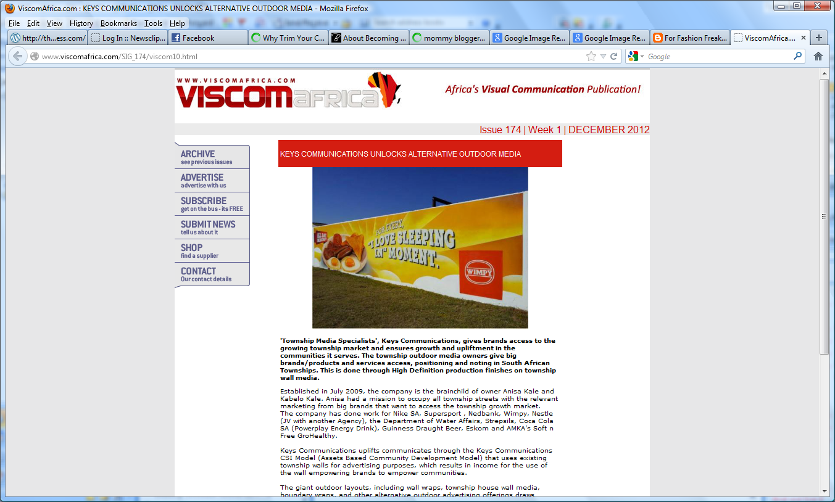

http://www.viscomafrica.com/SIG_174/viscom10.html